Assignment: Understanding and Maintenance of Networks

Section 1: Multiple Choice

1. What is the primary function of a router in a computer network?

Ans: c) Forwarding data packets between networks

1. What is the purpose of DNS (Domain Name System) in a computer network?

Ans: c) Converting domain names to IP addresses

1. What type of network topology uses a centralized hub or switch to connect all devices?

Ans: a) Star

1. Which network protocol is commonly used for securely accessing and transferring files over a network?

Ans: b) FTP

Section 2: True or False

5) A firewall is a hardware or software-based security system that monitors and controls incoming and outgoing network traffic based on predetermined security rules.

Ans: True

6) DHCP (Dynamic Host Configuration Protocol) assigns static IP addresses to network devices automatically.

Ans: False

7) VLANs (Virtual Local Area Networks) enable network segmentation by dividing a single physical network into multiple logical networks.

Ans: True

Section 3: Short Answer

8) Explain the difference between a hub and a switch in a computer  
network.

Ans:

|  |  |
| --- | --- |
| HUB | SWITCH |
| It is a broadcast device. | It is a point to pointdevice.(Multicast Device) |
| Works in physical layer of OSI model | Works in datalink / Network layer of OSI model |
| It cannot be used as a repeater. | It can be used as a repeater. |
| Used to connect devices to the same network. | Used to connect devices to the network. |
| Sends data in form of bits | Sends data in form of frames |
| It simply broadcasts the incoming packet. | It uses switching table to find the correct destination. |
| No security features | Provides VLANs and port security |
| Types are:- Active hub, passive hub and Intelligent hub. | Types are Layer 2 and Layer 3 switch. |

9) Describe the process of troubleshooting network connectivity issues.

Ans:

Step Of Troubleshooting Network

Step of Troubleshooting a Network

**Connectivity**

**Identify the problem**

**Network settings**

**Reboot the device**

**Physical connections**

**Identify the problem:**

Verify if the device has an IP address assigned by the router .

**Connectivity:**

Use the ping command followed by the IP address of the default gateway.

If ping is successful then connection is success.

Show like this.

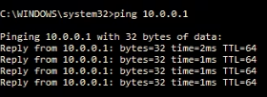

**If not success show like this..**

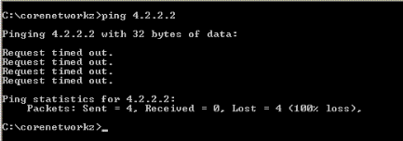

**Network settings:**

Make sure the device's network settings, such as IP address, subnet mask, and default gateway, are properly configured.

**Physical connections:**

Make sure the cables are securely connected and in good condition. Check the physical links between the device and the router or modem.

**Reboot the device:**

Try rebooting the device to see if it solves the problem. Simply turn it off and then back on.

Section 4: Practical Application

10) Demonstrate how to configure a wireless router's security settings to  
enhance network security.

Ans:

* Access your router's web interface.
* Go to the "Security" or "Wireless Security" tab.
* Select "WPA2-Personal" or "WPA3-Personal" as the security mode.
* Set a strong, unique password for the network.
* Enable encryption for network traffic if the option is available.
* Restrict the number of devices that can connect at once.
* Activate MAC filtering to prevent unauthorized devices from connecting.
* Enable the firewall to block unwanted traffic and protect the network.
* Update the router's firmware regularly to maintain the latest security enhancements.

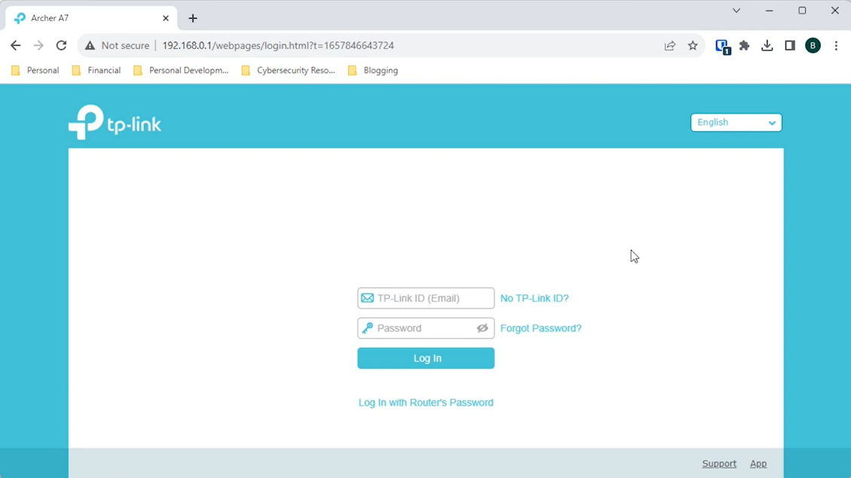

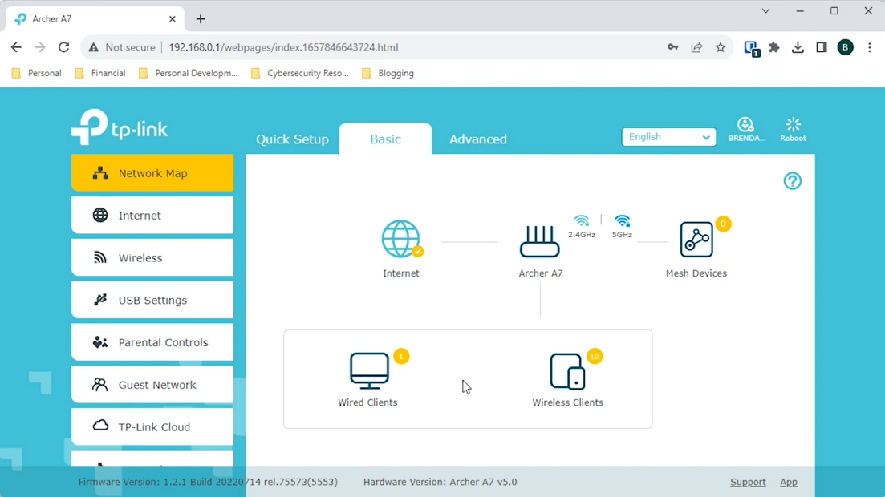

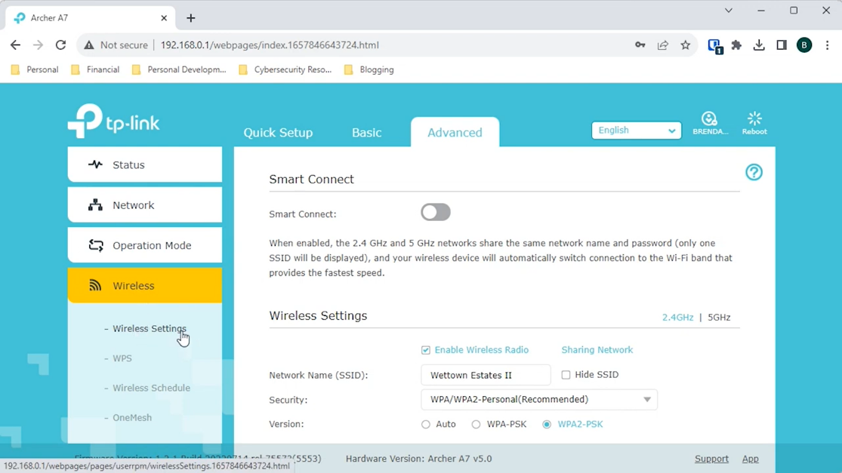

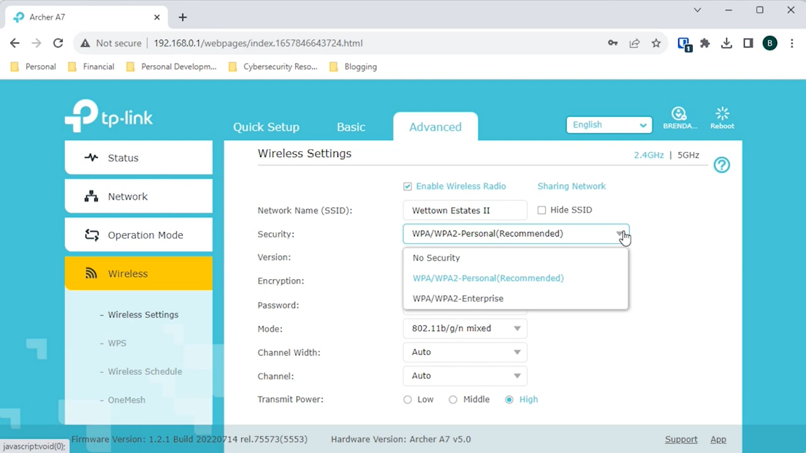

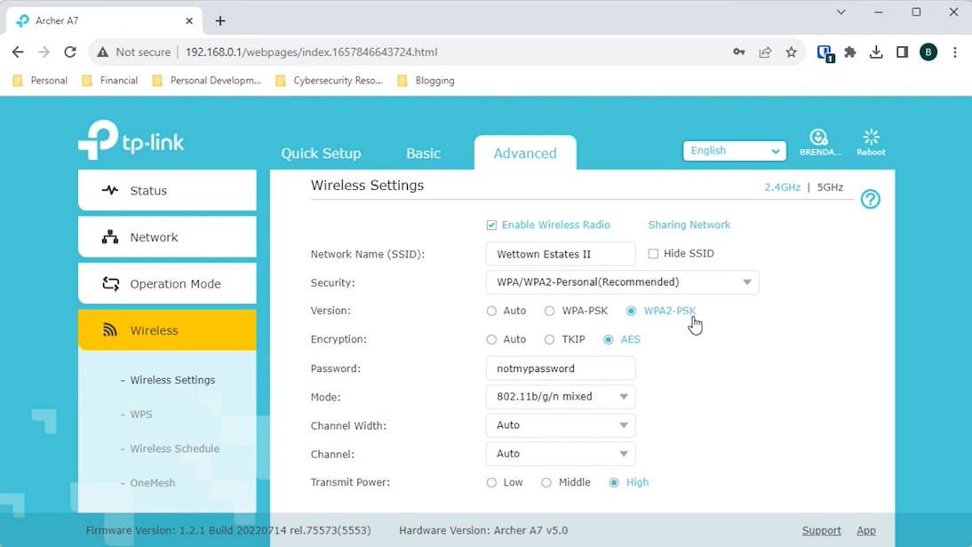

Section 5: Essay

11) Discuss the importance of network documentation and provide  
examples of information that should be documented.

Ans:

There are multiple benefits to having comprehensive network documentation. For instance, if a new employee joins the company, they can easily understand how the network is configured by referring to the documentation. Additionally, in case of any issues or during troubleshooting, the documentation provides a reliable reference point, helping to quickly resolve problems.

Having comprehensive network documentation offers numerous advantages. For instance, it provides a valuable resource for new employees who need to understand the network configuration and setup, enabling them to acclimate quickly and perform their tasks effectively. Additionally, detailed documentation serves as an essential reference during troubleshooting or resolving network issues. IT personnel can swiftly access the documented configurations and settings, identify problems, and implement solutions efficiently, thereby minimizing downtime and maintaining smooth network operations.

Overall, network documentation ensures continuity, facilitates onboarding, and enhances the troubleshooting process, making it an indispensable tool for any organization.